**Unit 2**

**Exercise 1**

First, let us create a new hard disk for the virtual machine. Then, we are going to create the following partitions:

• A NTFS primary partition of 2GB called PNTFS.

• An EXT4 primary partition of 2GB called PEXT4.

• An extended partition of 4GB.

• A logical partition of 2GB called PFAT32.

In order to do this we have to install the Operating System:

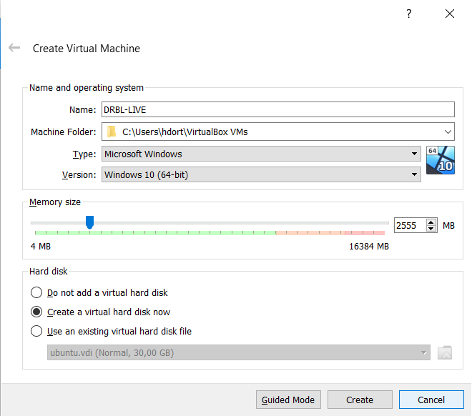Here we select the memory size, and the name of our Operating System.

The next step is to select the size to the file, in this case we chose 10 GB:

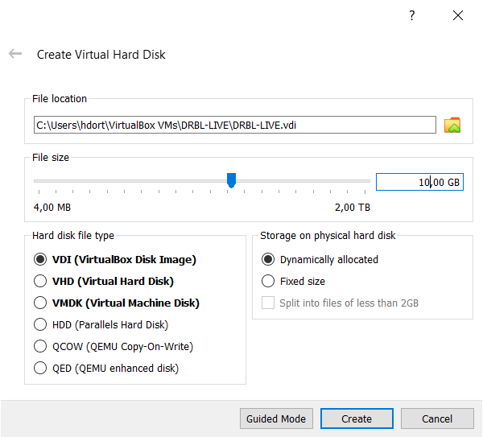

Then we have to create two disk, like the screen below, in order to have two diferents disk:

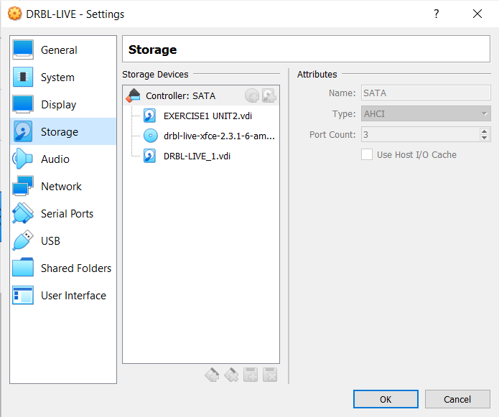

Now, it is time to start with the installation and the configuration:

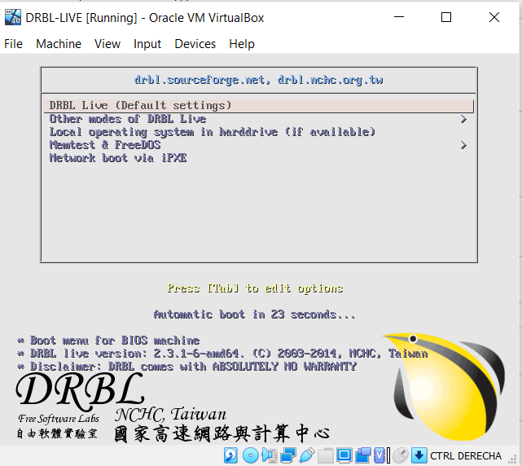

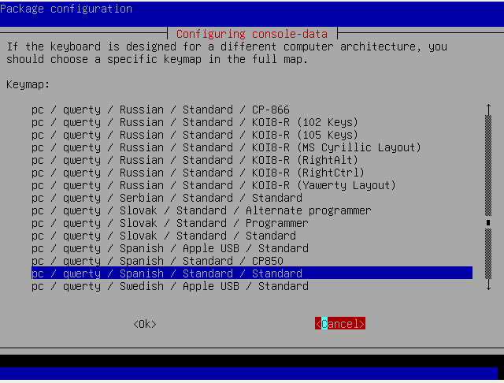Selected the keyboard language in order to not have any problema with our keyboard.

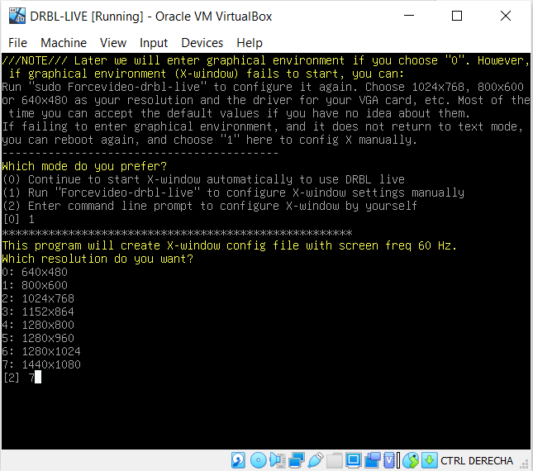Then we finish the configuration:

Now we can do the partitions:

We have to open the Disk Management and start the partitions.

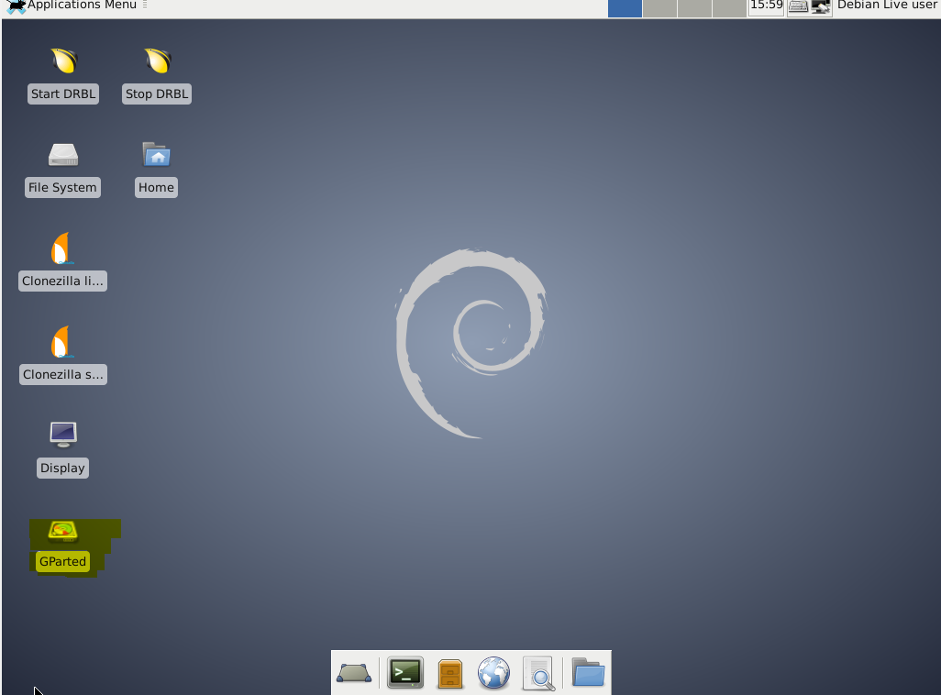

Then we have to right-button click on unallocated space

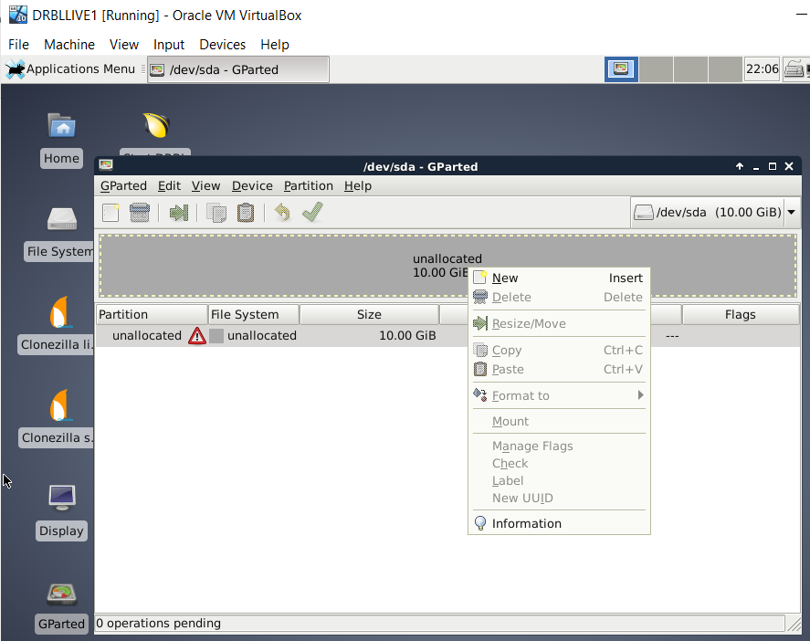

Then we are going to create a partition table form device option.

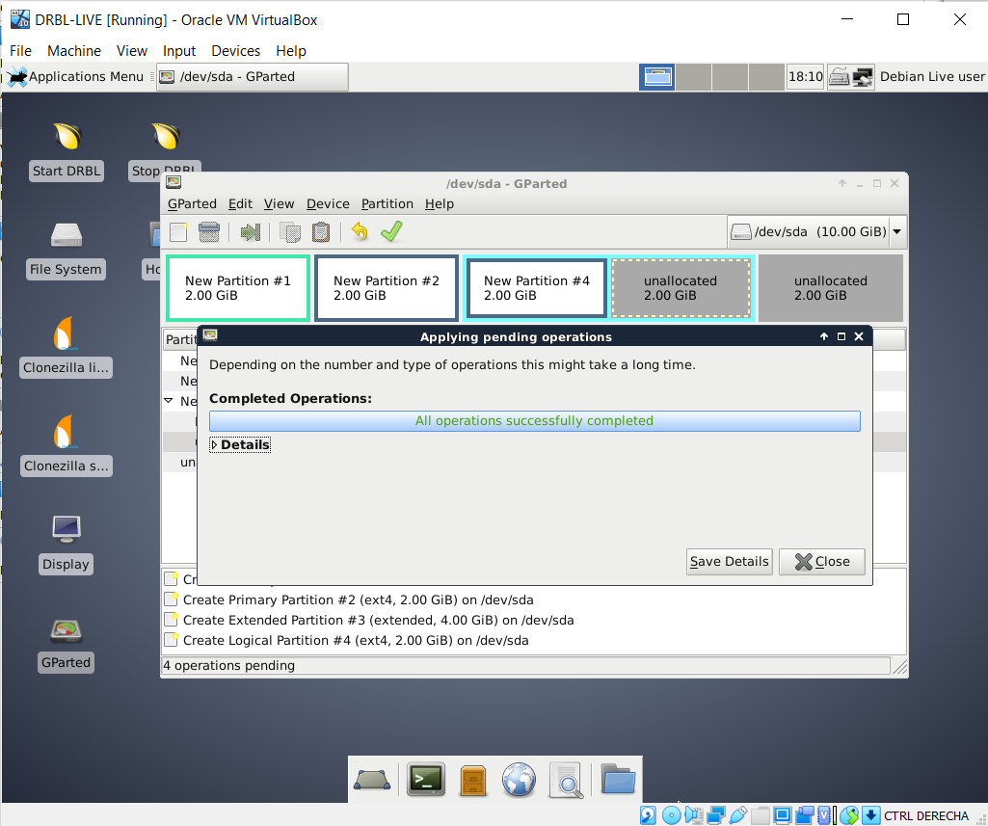

It is necesary to select a msdos type:

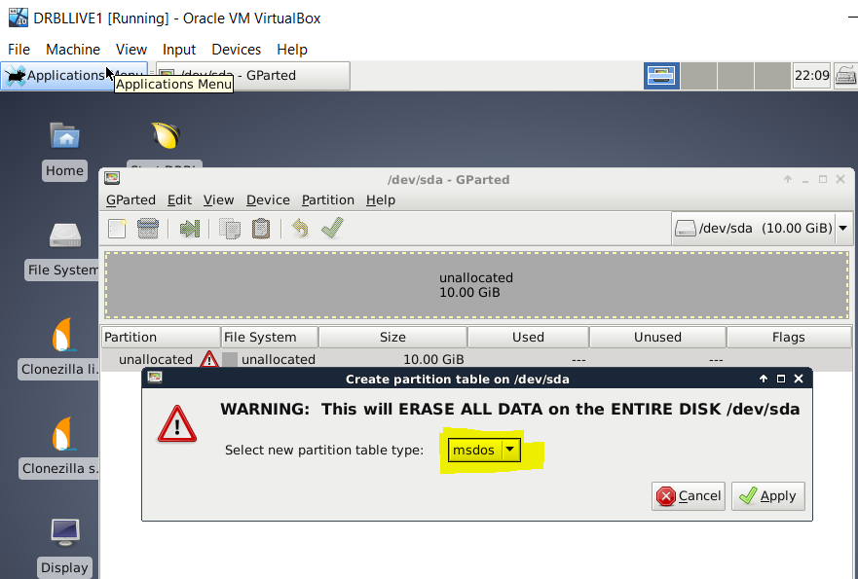

We have to right click on the anallocated space and select new, and lets create a primary partition of 2GB:

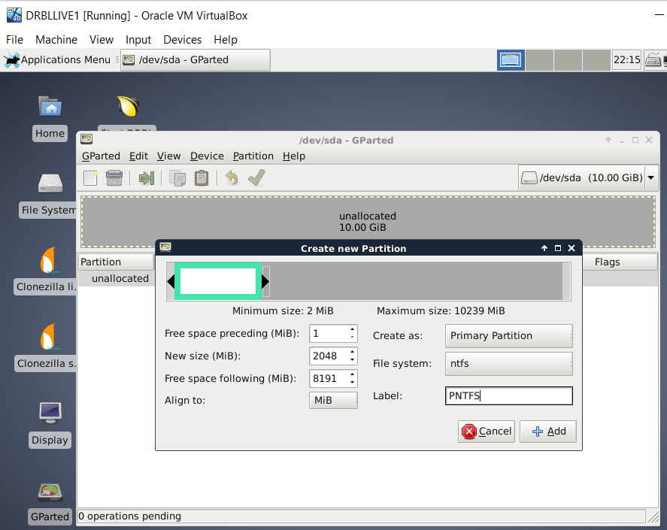

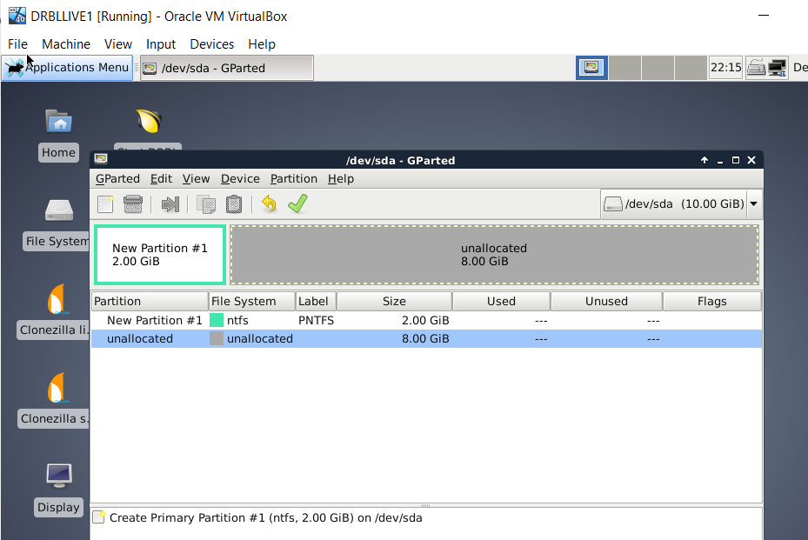

We need to create another partitions how is showed in the pictures below:

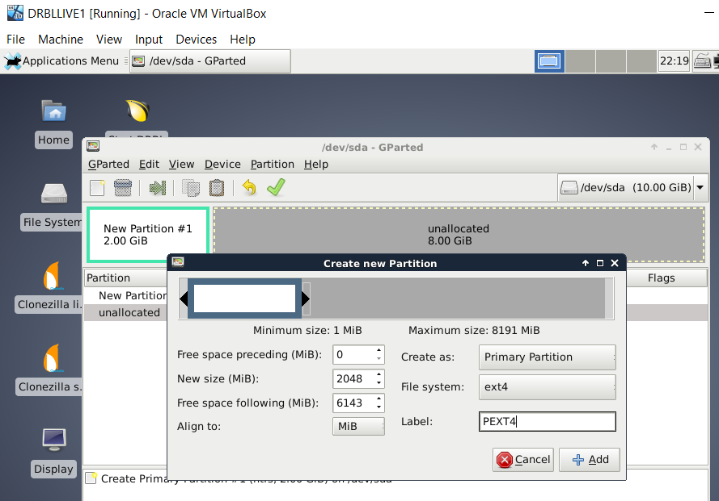

Now we need to create a extended partition. We set PREXTENDED as label.

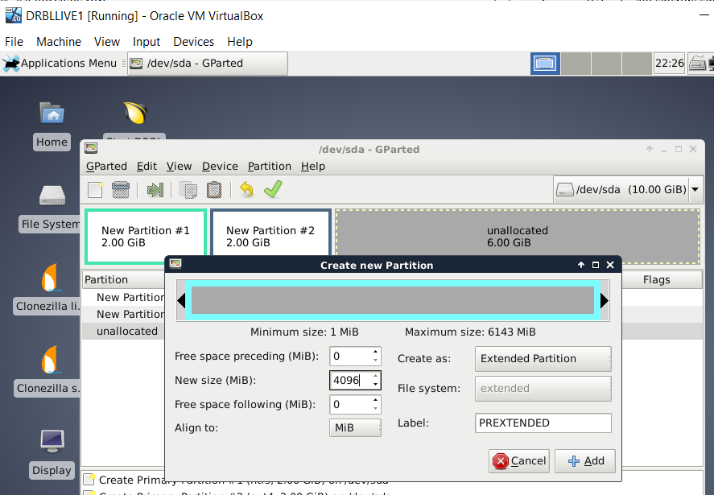

We create this extended partition in order to create a logical one.

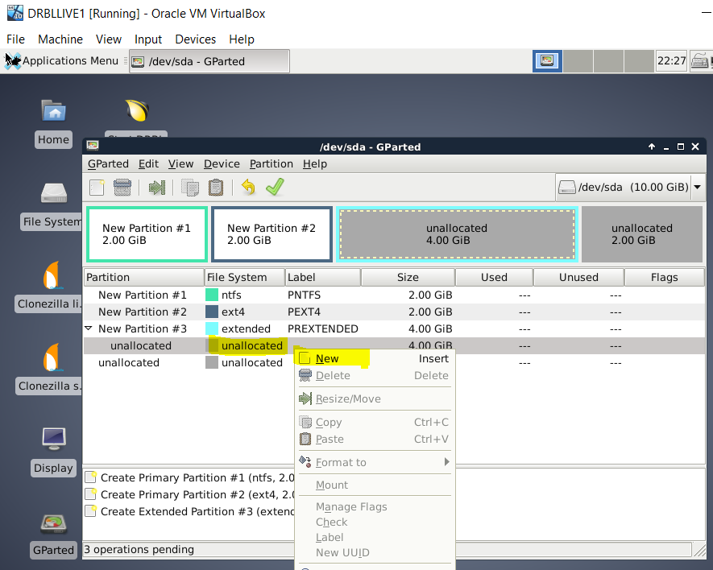

And finally, the partitions have to be like the screen below:

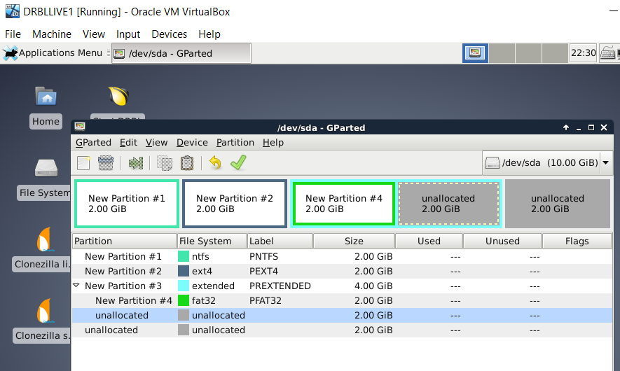

To confirm this step we have to click on the tick and apply:

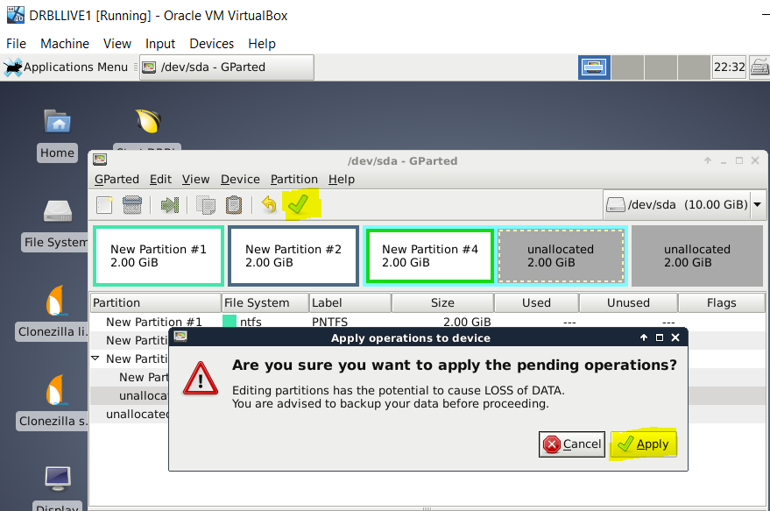

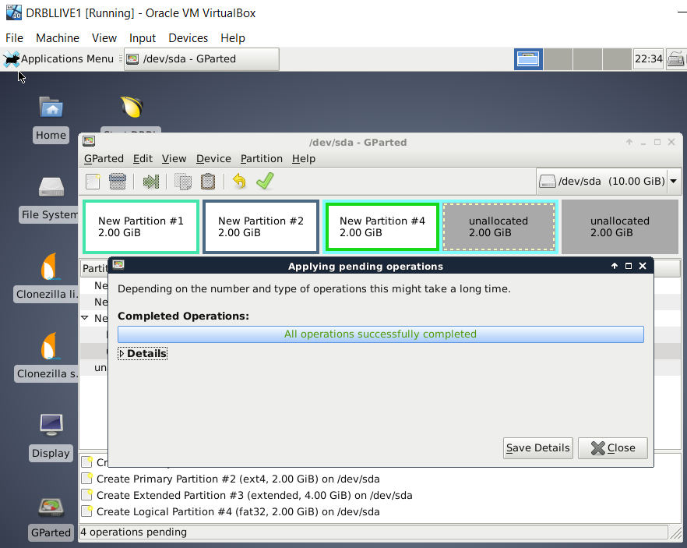

After that we have to close this vitual machine and open with Windows 10.

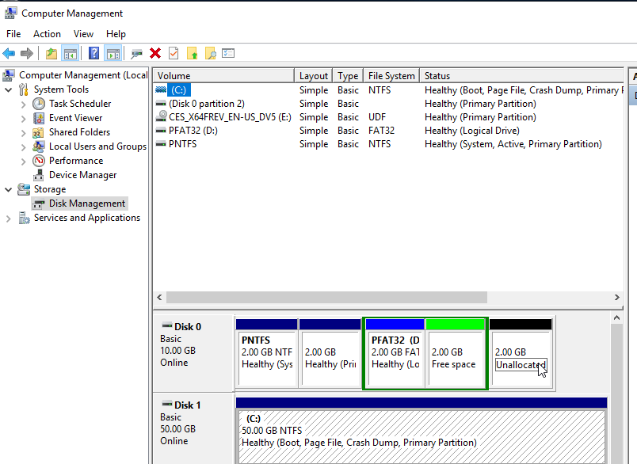

Answer the following questions

**1. Why is the file system not showed in the second partition?**

-The reazon is because the second partition was make like a EXT4 primary partition, and this partition is used to Linux, and Windows can not reconize this format.

**2. If you had to create a new partition to store 2 GB data, where would you put the partition in? Which file system should you use? Justify your answer.**

-We can use any free space but just because we are using Windows we must to use the file system NTFS, FAT16 or FAT32.